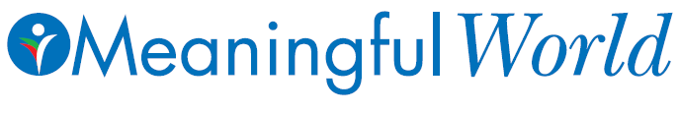

Intern Call: 2026-2027

Association for Trauma Outreach and Prevention (ATOP)

Mission:
At Meaningfulworld, the goal is to prepare a generation of conscientious individuals who are guided by love, peace, passion, and meaning. Meaningfulworld is dedicated to fostering a meaningful, peaceful, and just world in which every individual enjoys physical, mental, social, economic, and spiritual health. A sense of meaning, peace, and justice, although unique to each individual, is achieved through a transformative journey that integrates knowledge and experience with a sense of responsibility and reflection. This transformative process is also attained through healthy relationships that nurture open, honest, and transparent communication, insight into forgiveness, love and spiritual connection, and sacred activism.

Available Positions:
All internships are conducted under the supervision of both Dr. Ani Kalayjian-Founder and CEO, Board of Directors of ATOP, and the Intern Coordinator.
- Grant Writer/Researcher: Assisting the Grant Committee to research & write grants, apply for awards, disseminate the work through printed materials
- United Nations Internship: Presence is essential on Thursdays to attend international meetings & join DGC and CoNGO Committees. One year minimum.
- Web Support: Upload photos, press release, and reports on our website.
- Digital Media: International footage from our humanitarian missions. Successful candidates could make a short film for YouTube for educational outreach.
- Marketing Intern: Taking part in our active research team with local and international research from around the world.
- Fundraising & Outreach Intern: To maintain sustainability of our organization, organizing fundraising events for social gatherings to raise funds.
- Educational Coordinator and assistant: Managing monthly educational workshops.
Location: Although based in the New York Metropolitan Tri-State area, USA, other internships are welcomed. Internships are mainly virtual except the UN. Monthly meetings are virtual, mandatory on first Monday eve. Monthly training programs are mandatory and are hybrid.
Time commitment: 12 months–2 years, 5-6 hours a week (some internship less hrs)
Kindly send your resume, statement of purpose, internship position of interest, 3 goals consistent with our mission, 2 contacts for reference, to Dr. Kalayjian DrKalayjian@meaningfulworld.com, kindly visit: www.meaningfulworld.com

