Presents a symposium at
2021 Eastern Psychological Association (EPA) Annual Conference on
Suicide Prevention During Covid-19: Global Perspectives in 4 Regions
Samer Sabbour & Dr. Kalayjian
On 5 March 2021, Association for Trauma Outreach & Prevention (ATOP), Meaningfulworld members successfully presented a symposium at the Eastern Psychological Association’s (EPA) annual conference, which was held virtually. The Eastern Psychological association was founded in 1896 and is one of the oldest regional psychological associations in the nation. Its purpose, to advance science and profession through the dissemination of professional information about the field of Psychology, has been achieved since its founding by its conducting of annual meetings where members present on their latest advances in professional and scientific work. The EPA recently celebrated its 125th anniversary in 2020, and our team was honored to be a part of this year’s two-day conference that took place in spite of the global pandemic. Overall, there were 7 international programs including ATOP’s, delivered over the course of the conference, and attended by over 150 students and faculty.
Dr. Kalayjian, president and founder of ATOP presented at one of these symposiums: “Behavioral sciences at the United Nations: Past, present, & future trends'' which addressed the question: “What are the increasing roles of behavioral scientists at the United Nations?” and featured six NGO representatives and interns who highlighted their work alongside Psychology Coalition at the United Nations and challenges for Sustainable Development Goals. Other symposiums included themes such as: Improving mental health globally, behavioral science and the global agenda at the United Nations, and a keynote presentation by Dr. Kurt F. Geisinger addressed ‘Do psychological tests and assessments know foreign languages?’
Our symposium was entitled “Suicide prevention during the Covid-19 Pandemic: Global Perspectives” and was chaired by Dr. Kalayjian. The various presentations focused on addressing why suicide is increasing globally and what can be done to reduce this crisis. Team presentations reviewed global patterns in suicide across years and regions (especially during the COVID-19 pandemic), diverse strategies to reduce suicide, and specific case studies in four regions: Africa, the Caribbean, the Caucuses, and the Middle East. The table below highlights suicide related stats in those countries.
The first presenter was Mark Imus, Acting Coordinator of Meaningfulworld Outreach Committee, whose theme was “Transforming Trauma from Political Violence into Healing: Perspectives from Israel-Palestine.'' He discussed the work Meaningfulworld has done with regards to the Israel-Palestine conflict with the help of Meira Yasin. Mark provided background and history of the conflict and the impact the separation wall has had on the Palestinian population.
The next presentation was by Andrew Dolinar, Intern Coordinator, who highlighted our efforts to establish Armenia’s first suicide prevention lifeline during our Humanitarian Outreach Missions between 2016 and 2019. He provided statistics on suicide in Armenia and particular risk factors, including the recent war in Artsakh and the COVID-19 pandemic. He identified important aspects of the mission, including our 12-Step for Multi-Stakeholder partnerships, the ATOP suicide prevention Training Manuals and interventions used to train lifeline volunteers, lifeline structure, and outcomes.
Sahib Singh, United Nations Intern, presented next on the efforts of Meaningfulworld in Haiti since 2010. Sahib emphasized the cornerstone of our work in Haiti and the ongoing support we provide to the Meaningfulworld Chapter in Haiti. Sahib discussed the outcomes of our 14th Humanitarian Outreach Mission to Haiti in 2019 and the 12 specific goals achieved during this mission, including teaching Emotional Intelligence to the police, teachers, staff of orphanages, and children in 6 orphanages.
The last presenter was Samer Sabbour, United Nations Intern, who presented on Suicide Prevention in Nigeria during the team’s first mission to Nigeria in June 2019. After providing background information on the factors in Nigeria that prompted ATOP’s intervention, such as violence, war, gender inequalities, Samer identified ATOP’s three-prong approach: 1. Healing and Education, 2. Research and Publications, and 3. Policy Revisions, and Developing Sustainable Programs through the United Nations’ SDG’s. He then shared a breakdown of ATOP’s day-to-day programming in Nigeria with emphasis on the team’s workshops at universities, orphanages, churches, and the police department. Additionally, he also described our well received educational programs on radio stations.
A lively Q&A followed, with thoughtful questions from eager participants discussing involvement opportunities at ATOP, what made team members join this organization, how they could join Meaningfulworld, and what the team was planning next. We discussed our upcoming humanitarian mission to Armenia to address the war trauma, and the generational, collective, and vicarious traumas facing the nation.
Ultimately, the event was very successful. Special gratitude to Drs. Takooshian and Congress for their valuable assistance in planning of a 2-day international psychology programs at the Eastern Psychological Association Conference. We are in deep gratitude to EPA and are excited to begin working on collaborations with graduate students we developed relations during the conference for a joint publication project!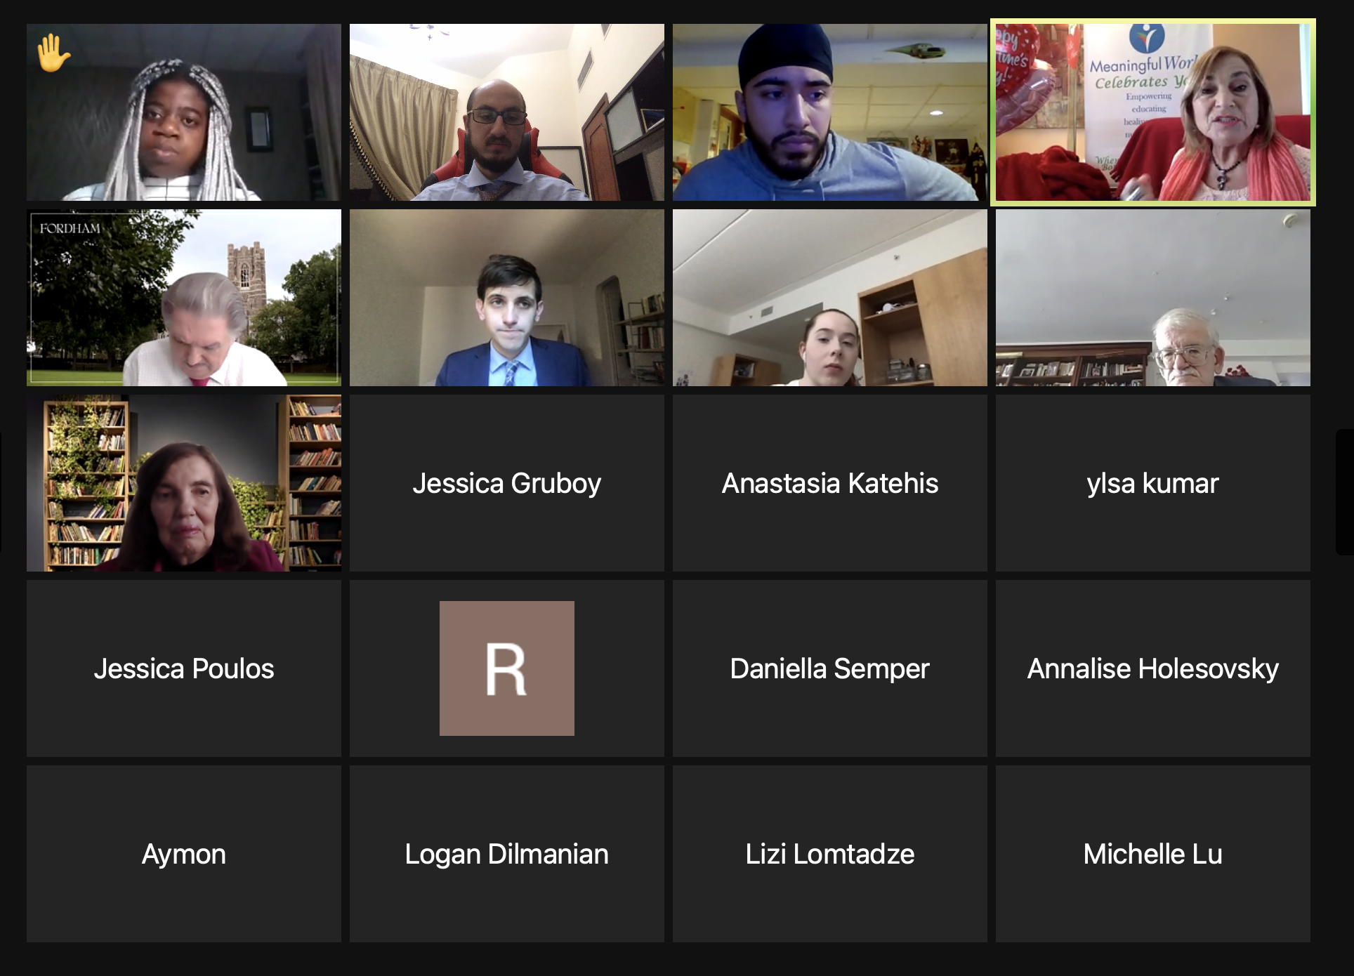
ATOP @ EPA 2021

Suicide and Suicide Related Stats Worldwide
Armenia | Haiti | Palestine | Nigeria
6.6 suicides per 100,000 people | - 11.7 suicides per 100,000 people | 1.8 suicides per 100,000 people | - 9.5 suicides per 100,000 people
- Self-reported suicide attempts by 15- to 16-year-old schools students indicated a lifetime  - rate of 4.1%  - 80.9% of students from Armenia, who reported having attempted suicide, also reported self-harm thoughts  Kokkevi, A., Rotsika, V., Arapaki, A., & Richardson, C. (2011) Adolescents’ self-reported suicide attempts, self-harm thoughts and their correlates across 17 European countries. Journal of Child Psychology and Psychiatry. 53(4). | - In Haiti, little is currently known regarding prevalence of, or risk factors associated with, depression and/or suicide  - Published studies of depression in Haiti reflect pre-2010 earthquake levels  Wagenaar, B.H., Hagaman, A.K., Kaiser, B.N., McLean, K.E., & Kohrt, B.A. (2012) Depression, suicidal ideation, and associated factors: a cross-sectional study in rural Haiti. BMC Psychiatry. | - Survey data from 14,303 participants across Middle Eastern countries indicated a 23.7% prevalence of suicidal ideation amongst palestinian students  - Prevalence of suicidal planning was 18.5%  - rate of suicidal thinking in Palestinian students was higher than that in other studies of adolescents from around the world, and was also higher than any other country in the Middle East that completed that same survey  Itani, T., Jacobsen, K.H., & Kraemer, A. (2017) Suicidal Ideation and planning among Palestinian middle school students living in Gaza Strip, West Bank and United Nations Relief and Works Agency (UNRWA) camps. International Journal of Pediatric Adolescent Medicine. 4(20). | - Suicidality reported to be common in persons living with HIV/AIDS, rates of suicide higher compared to general population  - Study found 34.7% of participants living with HIV/AIDS had suicidal ideations, compared to 4.7% of participants without HIV/AIDS  - 9.3% of participants living with HIV/AIDS had attempted suicide in past six months  Chikezie, U.E., Otakpor, A.N., Kuteyi, O.B., & James, B.O. (2012) Suicidality among individuals with HIV/AIDS in Benin City, Nigeria: A case-control study. AIDS Care. 24(7).

Recordings of 5 of the Symposia can be found here:
1. Symposium with students at the United Nations
https://fordham.zoom.us/rec/play/tJPWjOBc2SXhjIMhpjtVKso2OkYLngC0olh4uI9Ym_zXbcOP9v6E2xK YiUsvU_QTcTEVPmNsgsSNJXh3.TSPr2-C-79Zvk7dr?continueMode=true Passcode: Pv9&xB?C
2. Behavioral science at the UN: Past, present, future trends https://fordham.zoom.us/rec/share/-
yCH4Pj0B9_zyjC6nOFd4R1fcZrl0z8XpScbHFvFhIzZ1FgqFhNtsw9tvGb2aPdh.1bQtM38r4rxLmdum?startTime=161 4956502000
3. Improving the mental health of children: Abandoned, rejected, at-risk: https://fordham.zoom.us/rec/share/6jqI_RwESoCgyS_BUYZJ2Zecg1Zay-5MWJ62Qzr 6bdJCEIXSvzrCsz7bxL1f25h.UhNhs7lBgijD8Uk0
4. Symposium: Suicide Prevention During the COVID-19 Pandemic. https://fordham.zoom.us/rec/share/bd
BXiZwSFKaF1j8Hk94NTRoWL7TM0oWPWpK7vhS3dI_I6cuqnF52-
gQhp95yjrj.tcehrVDeoe44nl9_ Passcode: $#S9uFR7
5. Behavioral science in the global arena: (book authors) https://fordham.zoom.us/rec/share/lhEqsYJQZ8aCkj-XglOaLiaBr880kWRN3- m8yZWJtSOMqZf5syQFABeU7k4xbmlF.rHcUvtpmcjzrHXbo Passcode: U&LR8uL$
6. International invited address, Kurt Geisinger
https://fordham.zoom.us/rec/share/me4AOVaK560uRSE5VZ0C7UMWjSnStRFVIP9GXacryK4Bl_P2DW94tMclepPF 4vY.RUNuo2sV8d7f7zla Passcode: FB?0pVN#

