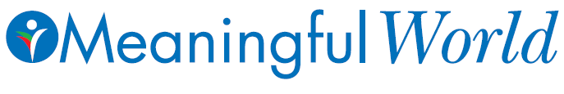
The Association for Trauma Outreach & Prevention (ATOP)
www.meaningfulworld.com
NY Office
185 E. 85th Street, New York, NY 10028
Phone: 1 (201) 941- 2266 E-mail: drkalayjian@Meaningfulworld.com

World Humanitarian Day: 25th Anniversary of ATOP Meaningfulworld’s Humanitarian Service
United Nations has declared 18 August as the World Humanitarian Day. A day dedicated to recognize humanitarian personnel and those who have lost their lives working for humanitarian causes.
The humanity is experiencing many traumas, both human-made and natural: famine, genocide, poverty, war, political conflicts, and multiple natural disasters. The words love, compassion, service to humanity, peace, care, courage, and hope come to mind when we speak about humanitarian work. It is a humanitarian who rushes to the world's hot spots to provide survivors with tools for healing, and with empathy. Humanitarians bring care and comfort in times of distress.
It is ATOP Meaningfulworld’s 25th Anniversary of Humanitarian Outreach. We have served in over 45 countries around the globe, as well as locally in over 12 states in USA. We have helped heal wounds with love and compassion; we have begun projects such as: 1. Sponsor a child in Haiti, Africa, Middle East, or Armenia, 2. Plant a tree project, 3. Meaningfulworld beautification project 4. Help establishing Neighborhood Associations, 5. Establish Peace and Forgiveness Gardens, 6. Transform trauma into lessons learned and post traumatic growth through love, empathy and forgiveness, 7. Establish Women’s and Men’s healing groups. We have faced multiple dangers such as our camp being bombed in the middle of the night (Palestine), the building next to us blown into pieces (Lebanon), hiding from evil militia in DR Congo, facing multiple epidemics in Haiti: Cholera, Malaria, Chickengunya, etc... For Meaningfulworld Ambassadors for Humanitarian Outreach and Prevention of Violence, there is no work too big, too small, or too dangerous.
Our Motto:
When one helps another, BOTH become stronger
On Tuesday, August 18 we invite you to celebrate with us our 25th Anniversary of service to humanity, and honor thousands of humanitarians around the world. We believe that the simple act of gratitude will strengthen our solidarity in promoting peace and harmony globally. If unable to join us personally, join us in spirit from wherever you are, and take a 5 minute silence to meditate, pray and reflect on the day, and share with others.
Please join us as we celebrate 25 years of service on the World Humanitarian Day in the Central Park NYC (entranec at 72nd Street at Central Park West), near John Lennon’s Strawberry Fields on Tuesday, 18 August, 2015, at 6:00 pm. We will have Soul-Surfing, sitting meditation, walking meditation with drumming.
RSVP: E-mail: info@Meaningfulworld.com, Phone: Dr Ani: 201-941-2266, www.Meaningfulworld.com
Website: https://www.facebook.com/MeaningfulWorldOfficial

